IFB 299 Final Release documentation

(Burndown chart, Design explanation)

James N9185305

Carl N8680400

Tuan N9590285

Nayereh N9506756

Joshua N9578820

Repository link :

https://github.com/joshua10808/IFB299-Property-Management-Group-12

Burndown Chart with Week by Week Information

## Graph1: Release Burndown Chart

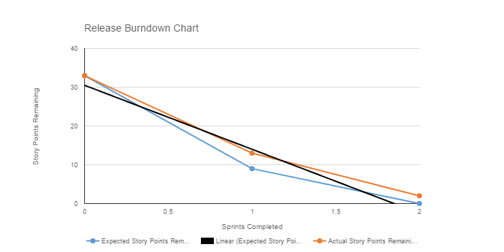

The above graph is the overall release burndown of our project, Property Management.

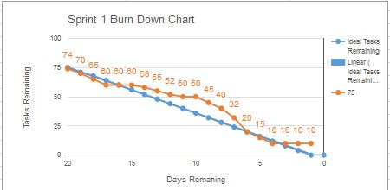

Below is a week by week breakdown of when user stories were completed and to what degree of satisfaction for Sprint 1. There is also a section for unfinished tasks, that were not completed for the sprint due to unforeseen circumstances that occurred after the release of the sprint plan.

Week1:

User Stories that were completed to satisfaction:

|  |  |  |
| --- | --- | --- |
| **Story ID** | **Story Title** | **Story Points** |
| **S03** | Staff login access | 2 |
| **T04** | Rental Tenants login access | 2 |
| **PT01** | Search Properties | 2 |
| **O02** | Add / Remove Properties | 4 |

Week2:

User Stories that were completed to satisfaction:

|  |  |  |
| --- | --- | --- |
| **Story ID** | **Story Title** | **Story Points** |
| **O03** | Manage Property Details | 2 |
| **PT03** | Property Information | 2 |
| **O01** | Secured Area for Owner | 2 |

Week3:

User Stories that were completed to satisfaction:

|  |  |  |
| --- | --- | --- |
| **Story ID** | **Story Title** | **Story Points** |
| **T05** | Emergency Communication | 4 |
| **S01** | Change allocated properties’ details | 1 |

Unfinished Tasks:

|  |  |  |
| --- | --- | --- |
| **Story ID** | **Story Title** | **Story Points** |
| **S02** | Booking Schedule Viewing | 1 |
| **PT02** | Book Inspection | 2 |

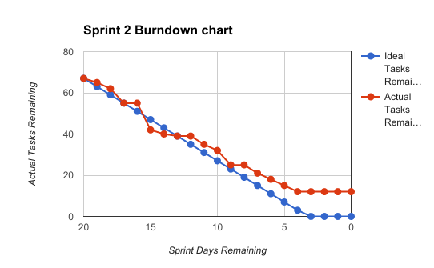

Below is a week by week breakdown of when user stories were completed and to what degree of satisfaction for Sprint 2. There is also a section for unfinished tasks, that were not completed for the sprint due to unforeseen circumstances that occurred after the release of the sprint plan.

Week1:

All Stories were underway but not yet completed satisfactorily.

Week2:

User Stories that were completed to satisfaction:

|  |  |  |
| --- | --- | --- |
| **Story ID** | **Story Title** | **Story Points** |
| **O04** | Receiving Queries | 2 |
| **O05** | Expense Tracking | 2 |

Week3:

User Stories that were completed to satisfaction:

|  |  |  |
| --- | --- | --- |
| **Story ID** | **Story Title** | **Story Points** |
| **T03** | Sending queries | 1 |
| **PT04** | Potential Tenant Account | 2 |

Unfinished Tasks

|  |  |  |
| --- | --- | --- |
| **Story ID** | **Story Title** | **Story Points** |
| **T04** | Payment Details | 2 |

Payment Details was unfinished due to constraints on time, the Developers knowledge of SQL databases and the Developer being sick during the development process.

**Design :**

To design the website we should consider what exactly the owner need and want. It is also crucial to understand the users as the end target needs. Achieving the task is required to study storyboards precisely. The website will be judged by the owner and users so developers should consider both sides. We tried to understand the owner's and user’s needs and interests.

There are many factors that affect the quality of a website. Although it needs to look good but the usability for both owners and users are very important.

The website users are looking for information about properties , in the other hands owners need to be able to run and transact with the website and they looking at it as their business.

We tried to classify the pages of the website based on the clear purposes. Therefore, we create two main categories of staff and tenants.

Users want to get information about properties quickly. We tried to make information easy to access by designing tables as a result of search to make properties information easy to read. We also tried to organize information by using headlines and tables instead of long sentences.

**Colors:** A well thought out colour palette can go a long way to enhance the user experience. We try to follow the latest fashion in web design, Neutral colors and white space which is very effective at giving our website a modern and uncluttered look.

**Images:** A picture can speak a thousand words, Choosing the right images for the website can make a connection with our target users. We embellished the look of our website with a high quality of a nice property.

We also try to design clickable button to navigate users to easy access to information and input their information.

Studies have identified that most of what people see is in the top and left of the screen and the right side of the screen is rarely seen. We used this user’s natural behaviour and display information in order of importance (left to right, and top to bottom).

We combined code into a central CSS or JavaScript file (this reduces HTTP requests) and minify HTML, CSS, JavaScript (compressed to speed up their load time).